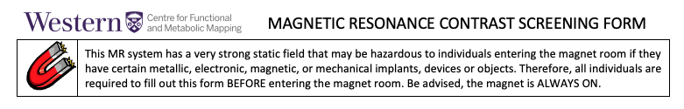
Please complete with your participant if the scheduled MRI requires
an injection of MRI contrast media:

On-Site Radiologist for Adverse Contrast Reaction:
On-Site Radiologist’s Pager Number:

Yes No Have you had a previous MRI with contrast dye?
Yes No Have you ever had a reaction to x-ray contrast?
Yes No Do you have sickle cell anemia?
Yes No Do you have a history of asthma?
Yes No Are you currently breastfeeding?
Yes No Have you had chemotherapy within the last 2 days?
Yes No Has your doctor ever told you that you have kidney problems?
Yes No Are you currently on dialysis?
Yes No Do you have diabetes?
Yes No Do you have high blood pressure?

Subject Information (to be completed by coordinator):
*Age (years): *Biological Sex: Male Female
*Height (cm): *Weight (kg): *Race: non-Black Black
*These variables affect eGFR calculation
Creatinine: eGFR: Calculator can be found on Cerner or
https://www.kidney.org/professionals/gfr_calculator

Additional Notes:

