Directions to Robarts Research Institute from the 401 Hwy

Take Hwy 401 to the Highbury Ave exit at London. Continue on Highbury Ave to Oxford Street ad turn left onto Oxford Street.

Sty on Oxford Street to Richmond Street and turn right.

Stay on Richmond Street to Windermere Rd and turn left.

The next set of lights is Perth Drive where you turn left. The University Hospital parking garage t hat you will use is on your right. See map below to get from parking to Robarts.

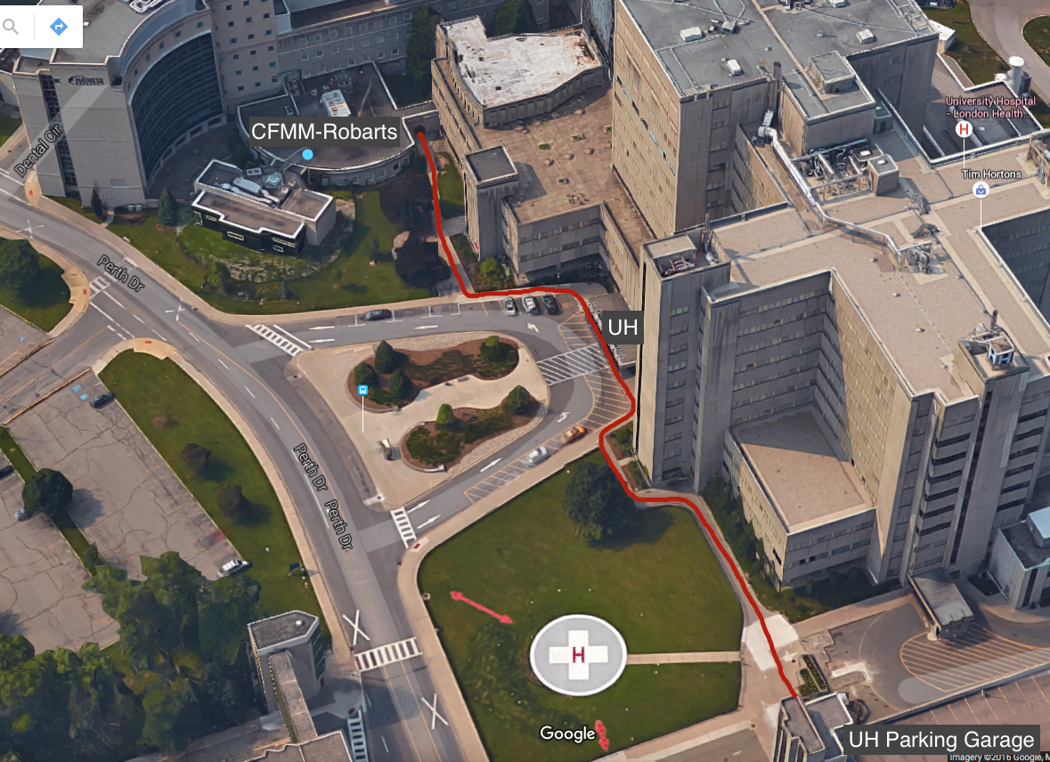

PS address: 43.012175 – 81:.273877
The Centre for Functional and Metabolic Mapping (CFMM)
Robarts Research Institute
339 Windermere Road is the University Hospital’s Main entrance.

There is a telephone on the wall to the left of the entry doors. Extensions are listed on the wall, but you may use the following:

- 25244 – Main Desk
- 24433 – 3T Magnet
- 24477 – 7T magnet

If calling from outside the University grounds the phone number for the switchboard is 519-931-5777 or 519-661-2111 and ask for one of the above extensions.

