Map A - aka “the Robarts-UH Link”
most convenient entrance from the UH Parkade

Many visitors to our facility are coming from off campus and/or will be parking in the University Hospital (UH) Parkade. Entry into the Robarts building nearest the CFMM can be accessed by taking the sidewalk to the right of the gazebo just off the horseshoe drive in front of the University Hospital. (See below map “A” for detailed direction).

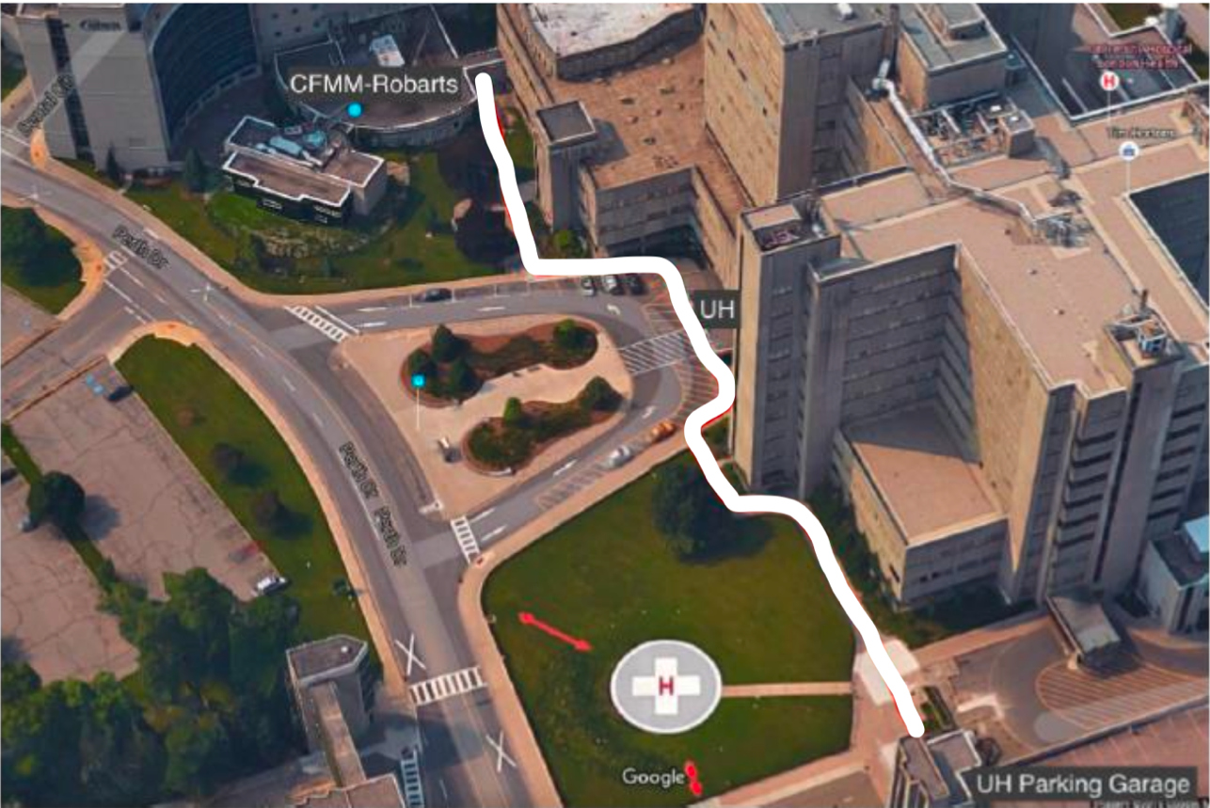
“Map A”

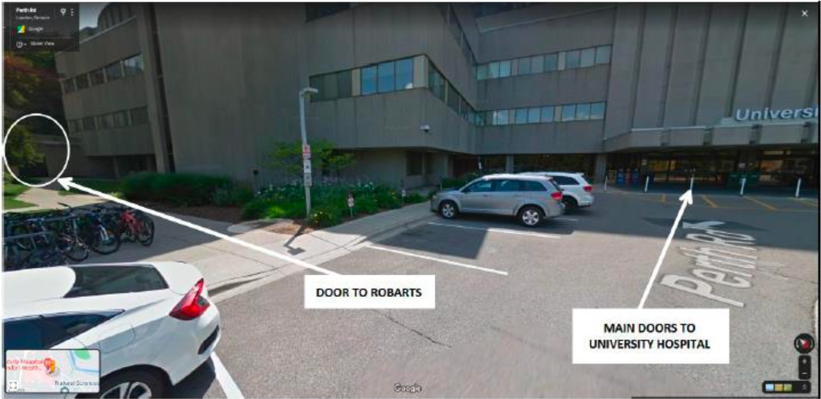

When entering through this door you can contact us from the telephone on the wall. Please call x25244 to have someone come and open this door for you.

If this entrance is not accessible, please first try calling 519-661-2111 x25244. If no one answers you may proceed around the building to Robart’s Main Entrance (off the Dentistry Circle) and check in with security – see instructions and “Map B” that follows.

CFMM MRI – Map B
Most convenient from Western Campus or alternative entrance from UH Parkade if Entrance A is locked/after hours

If you are coming from the direction of the Western University campus your closest entrance into Robarts is through the main front doors, off of Dentistry Circle.

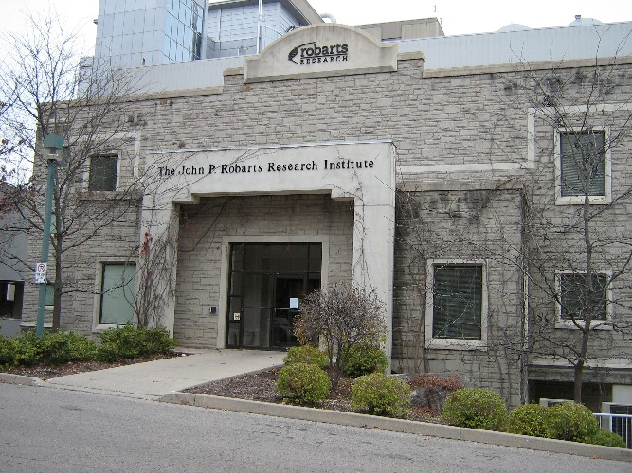
“Map B”

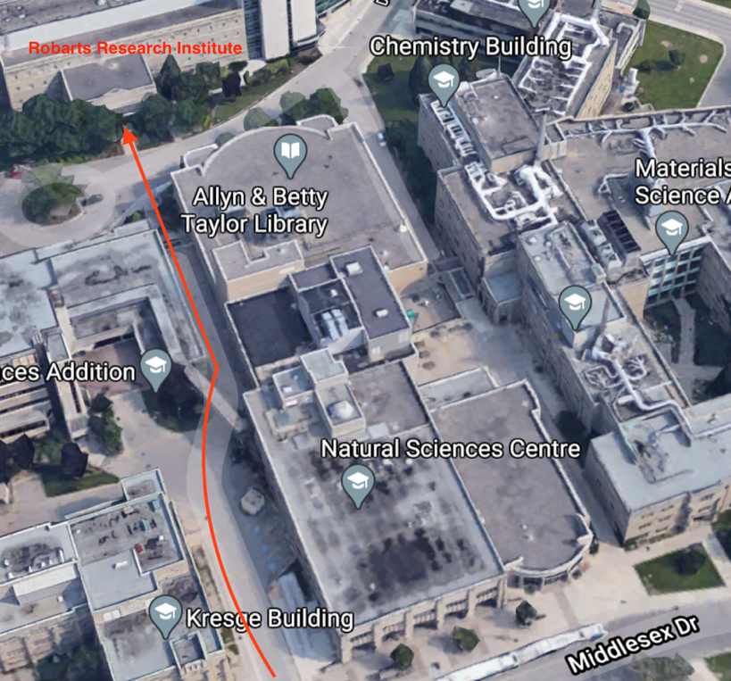
These doors currently remain locked but if you have card access you can swipe your card to unlock them. If you do not have card access press the “after hours delivery button” to the left of the doors to contact the security guard who will let you in.

Once in, please sign in at the security desk and inform the guard you are here to see “CFMM MRI”. Please have your STUDY NAME and PARTICIPANT ID available, if possible. Security will contact CFMM personnel (x25244) to let us know you are here. We will come up and bring you to your scan.

This entrance is also used when the side doors closest to the University Hospital are inaccessible due to it being after hours or construction. If Entrance A is unavailable, and no one answers when you try 519-661-2111 x 25244, then please proceed to Entrance B and sign in with security.
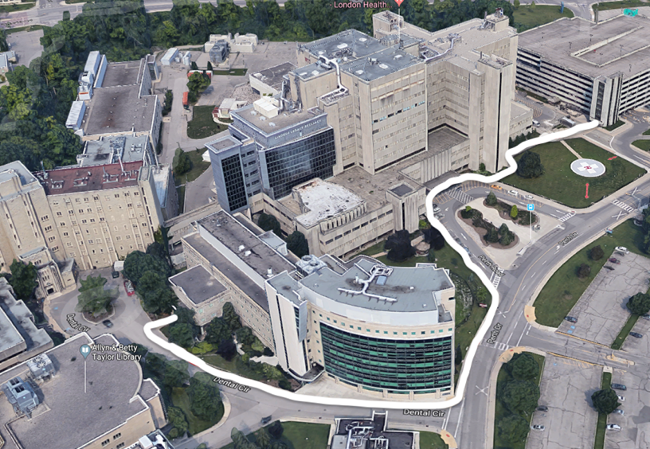

Here is the view if you are parking at University Hospital and following the white line to walk around Robarts to Entrance B.

